**AMERICAN INTERNATIONAL UNIVERSITY–BANGLADESH (AIUB)**

FACULTY OF ENGINEERING

Course name: Data Communication

Course code: COE 3201

Section: H

Semester: Spring 2023-24

Group-04

|  |
| --- |
|  |

|  |  |
| --- | --- |
| **NAME** | **ID** |
| EFFAT ARA | 22-46090-1 |
| MD. ABDULLAH SHISHIR | 22-46410-1 |
| FARJANA YESMIN OPI | 22-47018-1 |
| MD. ABU TOWSIF | 22-47019-1 |
| MOST. SAYMA KHATUN | 22-47035-1 |

Experiment No : 08

Experiment name: **Study of Frequency Division Multiplexing (FDM) using MATLAB**

Submission date: April 26th, 2024

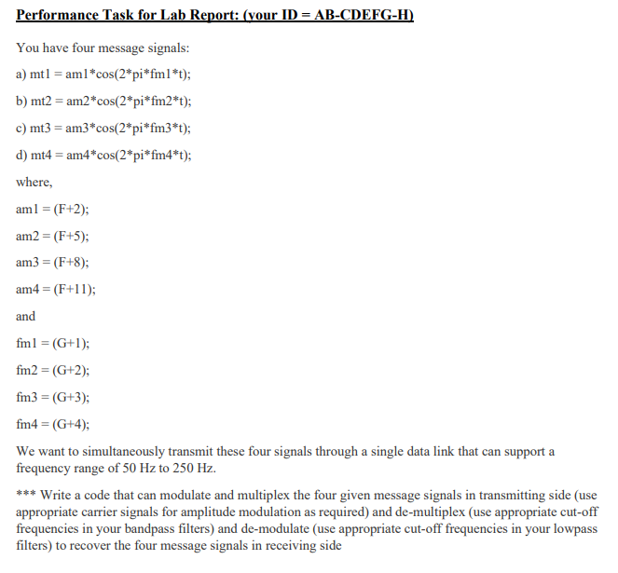

**ANSWER OF QUESTION 1**

|  |  |  |  |  |  |  |  |  |  |
| --- | --- | --- | --- | --- | --- | --- | --- | --- | --- |
| A | B | - | C | D | E | F | G | - | H |
| 2 | 2 | - | 4 | 7 | 0 | 1 | 9 | - | 1 |

|  |  |
| --- | --- |
| MATLAB Code | Output Figure |
| %HERE, F = 1, G = 9  clc;  clear all;  close all;    %% Message Signal Generation  fs = 4001; %Sampling Frequency  t = 0:1/fs:1-1/fs; %Generating Time axis    Am1 = 3; %Amplitude of First Message Signal  fm1 = 10; %Frequency of First Message Signal  m1 = Am1*cos(2*pi*fm1*t); % First Message Signal    Am2 = 6; %Amplitude of Second Message Signal  fm2 = 11; %Frequency of Second Message Signal  m2 = Am2*cos(2*pi*fm2*t); % Second Message Signal    Am3 = 9; %Amplitude of Third Message Signal  fm3 = 12; %Frequency of Third Message Signal  m3 = Am3*cos(2*pi*fm3*t); % Third Message Signal    Am4 = 12; %Amplitude of Fourth Message Signal  fm4 = 13; %Frequency of Fourth Message Signal  m4 = Am4*cos(2*pi*fm4*t);  %% Carrier Signal Generation  Cm1 = 1; %Amplitude of First Carrier Signal  fc1 = 50; %Frequency of First Carrier Signal  c1 = Cm1*cos(2*pi*fc1*t); % First Carrier Signal    Cm2 = 1; %Amplitude of Second Carrier Signal  fc2 = 100; %Frequency of Second Carrier Signal  c2 = Cm2*cos(2*pi*fc2*t); % Second Carrier Signal    Cm3 = 1; %Amplitude of Third Carrier Signal  fc3 = 200; %Frequency of Third Carrier Signal  c3 = Cm3*cos(2*pi*fc3*t); % Third Carrier Signal      Cm4 = 1; %Amplitude of Third Carrier Signal  fc4 = 250; %Frequency of Third Carrier Signal  c4 = Cm4*cos(2*pi*fc4*t); % Third Carrier Signal      %% Composite Signal Generation  x = (m1).*c1+(m2).*c2+(m3).*c3+(m4).*c4;    % Plotting the Signals in Time-Domain and Frequency-Domain  figure  subplot(3,1,1)  plot(t,m1)  xlabel('time')  ylabel('amplitude')  title('Message Signal 1 in Time Domain')  ylim([-Am1 Am1])  subplot(3,1,2)  plot(t,m2)  xlabel('time')  ylabel('amplitude')  title('Message Signal 2 in Time Domain')  ylim([-Am2 Am2])  subplot(3,1,3)  plot(t,m3)  xlabel('time')  ylabel('amplitude')  title('Message Signal 3 in Time Domain')  ylim([-Am3 Am3])    M1 = abs(fftshift(fft(m1)))/(fs/2); %Fourier Transformation of m1  M2 = abs(fftshift(fft(m2)))/(fs/2); %Fourier Transformation of m2  M3 = abs(fftshift(fft(m3)))/(fs/2); %Fourier Transformation of m3  X = abs(fftshift(fft(x)))/(fs/2); %Fourier Transformation of x  f = fs/2*linspace(-1,1,fs);  figure  subplot(3,1,1)  stem(f,M1)  xlabel('frequency')  ylabel('amplitude')  title('Message Signal 1 in Frequency Domain')  axis([-10 10 0 2.5])  subplot(3,1,2)  stem(f,M2)  xlabel('frequency')  ylabel('amplitude')  title('Message Signal 2 in Frequency Domain')  axis([-10 10 0 3.5])  subplot(3,1,3)  stem(f,M3)  xlabel('frequency')  ylabel('amplitude')  title('Message Signal 3 in Frequency Domain')  axis([-10 10 0 4.5])  figure  subplot(2,1,1)  plot(t,x)  xlabel('time')  ylabel('amplitude')  title('Composite Signal in Time Domain')  subplot(2,1,2)  stem(f,X)  xlabel('frequency')  ylabel('amplitude')  title('Composite Signal in Frequency Domain')  axis([-270 270 0 2.5])    %% Passing the Composite Signal Through Bandpass Filter  [num1, den1] = butter(5, [(fc1-fm1-6)/(fs/2),(fc1+fm1+6)/(fs/2)]);  %Butterworth Filter Window Determining for Bandpass Filter  bpf1 = filter(num1,den1,x); %Filtering is done here    [num2, den2] = butter(5, [(fc2-fm2-6)/(fs/2),(fc2+fm2+6)/(fs/2)]);  %Butterworth Filter Window Determining for Bandpass Filter  bpf2 = filter(num2,den2,x); %Filtering is done here    [num3, den3] = butter(5, [(fc3-fm3-6)/(fs/2),(fc3+fm3+6)/(fs/2)]);  %Butterworth Filter Window Determining for Bandpass Filter  bpf3 = filter(num3,den3,x); %Filtering is done here    % Mixing  z1 = 2*bpf1.*c1;  z2 = 2*bpf2.*c2;  z3 = 2*bpf3.*c3;    %% Passing the Mixed Signals Through Lowpass Filter    [num4, den4] = butter(5, (fm1+3)/(fs/2)); %Low pass filter is made here  rec1 = filter(num4,den4,z1); %Filtering is done here    [num5, den5] = butter(5, (fm2+3)/(fs/2)); %Low pass filter is made here  rec2 = filter(num5,den5,z2); %Filtering is done here    [num6, den6] = butter(5, (fm3+3)/(fs/2)); %Low pass filter is made here  rec3 = filter(num6,den6,z3); %Filtering is done here    % Plotting the Received Signals in Time-Domain and Frequency Domain  figure  subplot(3,1,1)  plot(t,rec1)  xlabel('time')  ylabel('amplitude')  title('received signal 1 in time domain')  ylim([-Am1 Am1])    subplot(3,1,2)  plot(t,rec2)  xlabel('time')  ylabel('amplitude')  title('received signal 2 in time domain')  ylim([-Am2 Am2])    subplot(3,1,3)  plot(t,rec3)  xlabel('time')  ylabel('amplitude')  title('received signal 3 in time domain')  ylim([-Am3 Am3])    R1 = abs(fftshift(fft(rec1)))/(fs/2); %Fourier Transformation is done here  R2 = abs(fftshift(fft(rec2)))/(fs/2); %Fourier Transformation is done here  R3 = abs(fftshift(fft(rec3)))/(fs/2); %Fourier Transformation is done here    figure  subplot(3,1,1)  stem(f,R1)  xlabel('frequency')  ylabel('amplitude')  title('received signal 1 in frequency domain')  xlim([-10 10])    subplot(3,1,2)  stem(f,R2)  xlabel('frequency')  ylabel('amplitude')  title('received signal 2 in frequency domain')  xlim([-10 10])    subplot(3,1,3)  stem(f,R3)  xlabel('frequency')  ylabel('amplitude')  title('received signal 3 in frequency domain')  xlim([-10 10]) |  |